#include<stdio.h>

int main()

{

char name[100];

char father_name[100];

char address[200];

char course[100];

char reg_no[50];

char email[100];

long long int contact_number;

int tenth_marks;

int twelfth_marks;

float cutoff;

char certificates[300];

char skills[300];

printf("***********BIO-DATA**********");

printf("\n Enter your name:");

scanf(" %[^\n]", name);

getchar();

printf("\nEnter your father's name:");

scanf("%s",father_name);

getchar();

printf("\nEnter your course: ");

scanf(" %s",course);

getchar();

printf("\nEnter your email id:");

scanf(" %s", email);

getchar();

printf("\nEnter your registration number: ");

scanf(" %s", reg_no);

getchar();

printf("\nEnter your contact number: ");

scanf(" %lld",&contact_number);

getchar();

printf("\nEnter your 10th marks: ");

scanf("%d", &tenth_marks);

getchar();

printf("\nEnter your 12th marks: ");

scanf("%d", &twelfth_marks);

getchar();

printf("\nEnter your cutoff: ");

scanf("%f", &cutoff);

getchar();

printf("\nEnter any certificates : ");

scanf(" %[^\n]", certificates);

getchar();

printf("\nEnter your skills: ");

scanf(" %[^\n]", skills);

getchar();

printf("\nEnter your address: ");

scanf(" %[^\n]", address);

getchar();

//display the biodata

printf("\n--- Biodata ---\n");

printf("Name: %s\n", name);

printf("Father's name:%s\n",father_name);

printf("Address: %s\n",address);

printf("Course: %s\n", course);

printf("Registration Number: %s\n",reg_no);

printf("Email ID: %s\n",email);

printf("Contact Number: %lld\n",contact_number);

printf("10th Marks: %d\n", tenth_marks);

printf("12th Marks: %d\n", twelfth_marks);

printf("Cutoff: %.1f\n",cutoff);

printf("Certificates: %s\n",certificates);

printf("Skills: %s\n", skills);

return 0;

}

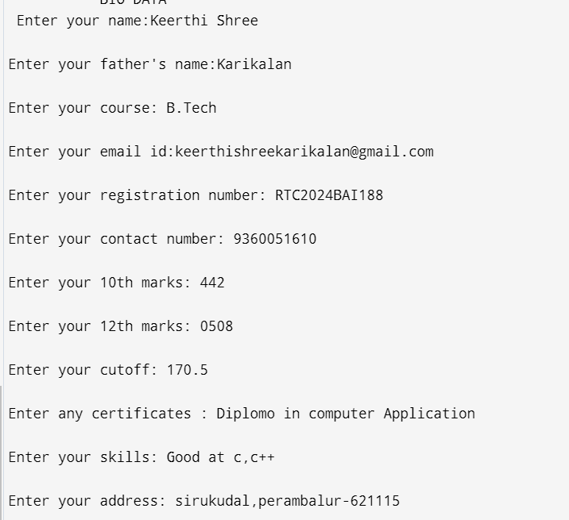

**Output:**

